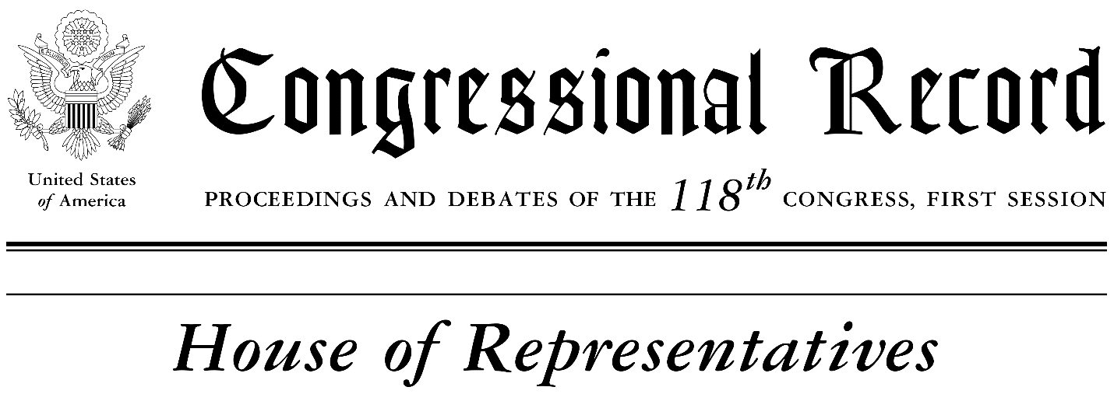

February 22, 2023

Mr. Speaker, I rise today to honor a true Tampa Bay historian who has served this community with great distinction for many decades. Mr. Charles “Fred” Hearns is one of the foremost historians of Tampa Bay and Florida history. And, since 2021, he has served as the first Curator of Black History for the Tampa Bay History Center (TBHC).

Mr. Hearns was born in the Bronx, NY and grew up in East Tampa, Florida, graduating in 1966 from Middleton High School, the first high school for African Americans in Hillsborough County. He later went on to further his education at the University of South Florida earning a bachelor’s degree in english/journalism and a master’s degree in Africana studies. Mr. Hearns also holds a master’s degree in human services from Springfield College (Distinguished Graduate Award). He is the father of four adult children, sons Charles F. (Ricky) Hearns Jr. and Marcel Charles Fred Hearns, and daughters Cassanda Franklin and Charaneka Johnson. He also has five grandchildren.

He began his career as a journalist working for the Florida Sentinel Bulletin, St. Petersburg Times, Tampa Tribune, Ft. Lauderdale Sun Sentinel and then in the Office of Public Contacts for Southern University in Baton Rouge, La. In 1975, Mr. Hearns began a 32-year career with the City of Tampa and became its human rights director in 1992. He retired as director of the Department of Community Affairs in 2007.

During his tenure with the City of Tampa, Mr. Hearns worked on several major projects including leading the charge as president of the Middleton High School Alumni Association to reestablish his alma mater where a Pavilion now stands in his honor. He also worked as a consultant for the revitalization of the Perry Harvey, Sr. Park project and was a founding member of several civic organizations in the city such as the 78th Street Improvement Association, the Ada T. Payne Friends of the Urban Libraries and the Robert W. Saunders Library Foundation, Inc. Mr. Hearns also worked as a consultant for the ENCORE housing project in Tampa. He served on the Friends of the Riverwalk and on the Florida Advisory Committee of the U.S. Commission on Civil Rights. In 2014, he was awarded the Robert Saunders Award for Community Service.

Mr. Hearns continues to lift the Tampa Bay community through his church, Allen Temple AME, and his fraternity, the Omega Psi Phi Fraternity, Inc. where he was initiated into the Pi Iota Chapter in 1977. Mr. Hearns served in numerous roles for the fraternity including as chair of the Just Gents program, which mentors young African American male students from Ernest Everett Just Elementary School.

Mr. Hearns has a deep love for this community and is constantly fighting to ensure everyone understands that Black History is everyone’s history. Sparked by his mentorship with Robert Saunders and the publication of Mr. Saunders’ book, Bridging the Gap, Mr. Hearns started to have a deep interest in local history. In 2005, he started his own tourism business, Fred Hearns Tours, LLC, which included both bus and walking tours of Tampa’s African American history. The next year, he wrote an autobiographical book titled, Getting It Done: Rebuilding Black America Brick By Brick. Mr. Hearns is the president emeritus of the Tampa Bay Chapter of the Association for the Study of African American Life and History (ASALH).

Mr. Speaker, on behalf of a grateful Tampa Bay community, during this Black History Month, we salute and honor Mr. Charles “Fred” Hearns for ensuring that history is written truthfully, fully and with a persistent shining a light on the struggles, contributions and success stories of our local unsung Black neighbors.

Sincerely,
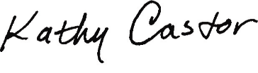
Kathy Castor
United States Representative
Florida – District 14

