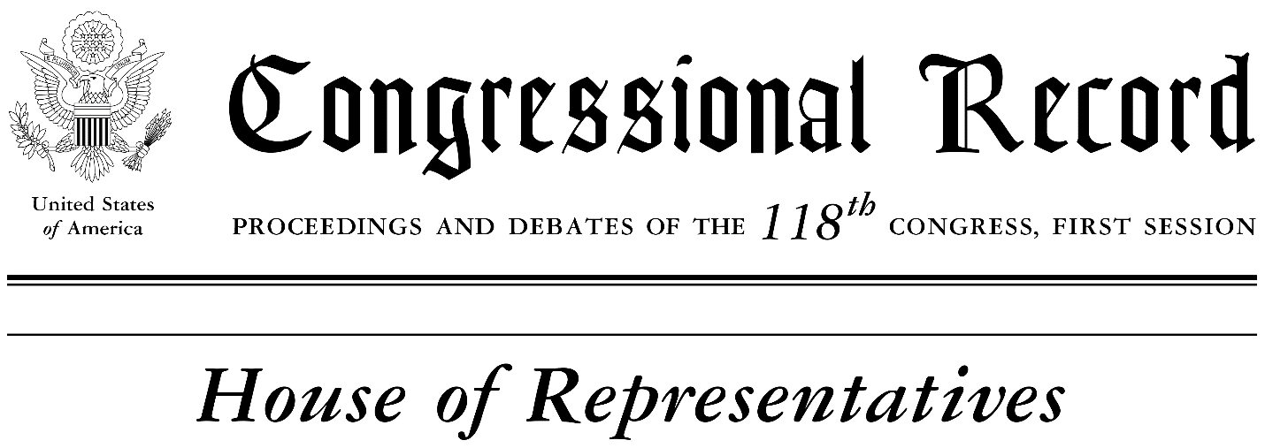

February 22, 2023

Mr. Speaker, I rise today to honor a great educator and leader in the Tampa Bay community, Dr. Davina Arleen Jones.

Dr. Jones is one of six children, born and raised in the Tampa Bay area. Her mother worked for the county library as a book processor and her father was a city bus operator while also serving as a full-time pastor. Dr. Jones’ parents instilled in her and her siblings the importance of commitment, leadership, and the spiritual faith – values she holds close to this day. At the early age of 13, a young Davina Jones gave her first public speech at a Church of God In Christ (COGIC) youth convention.

When she was a young student, Dr. Jones was enrolled in Exceptional Student Education (ESE) in Hillsborough County Public Schools due to the many challenges in her life, but the challenges would only reveal her drive for education and excellence. Through hard work and perseverance, Dr. Jones went on to graduate from Bethune-Cookman University with a bachelor’s degree in speech communication. She later went on to receive her master’s degree in interpersonal communications and her doctorate in communication studies from Bowling Green State University. These significant accomplishments led Dr. Jones to author “From ESE to PHD: Discovering your hidden potential.” She is also the author of “Choices: What singles ought to know and what married people wished they had learned.”

Dr. Jones served as a frontline partner as Florida and our nation prepared to receive and embrace the historic Dr. Mary McLeod Bethune statue in the Statuary Hall of the U.S. Capitol in 2022. Dr. Bethune's statue replaced the statue of a Confederate general that stood since the Jim Crow era and Dr. Jones advocated for Dr. Bethune as a far superior representative of the values and diversity of the Sunshine State. Dr. Jones continues to lift her community as a proud member of Delta Sigma Theta Sorority, Inc., a former president of the Mary McLeod Bethune National Alumni Association Hillsborough Chapter, a former president of the Bethune Cookman National Association Hillsborough Chapter, and Big Brothers and Big Sisters. Dr. Jones also actively collaborates with the African American Task Force for Hillsborough County Public Schools leadership.

Dr. Jones also continues to provide faith-based community leadership throughout the City of Tampa. She is the Assistant Spiritual Leader of Today’s Church Tampa Bay and former lead pastor and teacher of the Greater Love Spiritual Center. In 2015, Dr. Jones moved on her desire to educate and inspire passion to our younger generation when she founded GREAT Camp, a comprehensive program for teens and preteens that offers guidance and development in a variety of topics and skills such as civics development, health & wellness, and financial literacy. Considering all her education, hard work and accomplishments, Dr. Jones stated that her greatest achievement in life was becoming aware of the power of love, the love for oneself and the love for others through God.

Throughout the years, Dr. Jones has instructed public speech communication courses across the State of Florida. Using her expertise and experience, she has provided higher education level instruction to aspiring journalists, marketers and educators within our communities. Dr. Jones served as an assistant professor teaching speech communication at her alma mater Bethune-Cookman in 2001; she became a professor at Florida State College at Jacksonville and she is currently provost and special assistant to the president for equity, diversity and inclusion at Pasco-Hernando State College in Wesley Chapel. She continues her work among Pasco-Hernando State College leadership ensuring that all students receive the education they deserve.

Mr. Speaker, on behalf of the Tampa Bay community, this Black History Month, I am proud to recognize the courage, leadership, and spirit of excellence of Dr. Davina Arleen Jones and her many examples of service she provides our communities.

Sincerely,
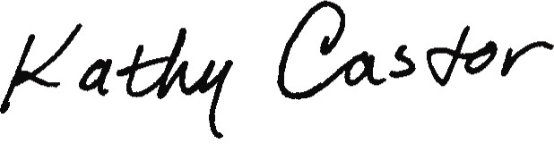
Kathy Castor
United States Representative
Florida – District 14

